**Assignment: ER-Diagram Design**

**Question 1: University Management System**

Problem Statement:

A university wants to maintain data about Students, Courses, Faculty, and Departments. The university management has provided the following requirements:

1. Each student has a unique roll number, name, email, phone number, and date of admission.

2. A student can enroll in many courses, and each course can have many students.

3. Each course has a course ID, course name, credits, and is offered by exactly one department.

4. Each department has a department ID, department name, and location.

5. Each faculty member has a faculty ID, name, designation, and email.

6. A faculty can teach many courses, but a course can be taught by only one faculty.

7. A student is assigned to exactly one faculty advisor.

Tasks:

1. Identify Entities & Attributes – List out all entities and their attributes (mention primary keys).

|  |  |  |
| --- | --- | --- |
| **Entity** | **Attributes** | **Primary Key (PK)** |
| **Student** | RollNo, Name, Email, Phone, DateOfAdmission | RollNo |
| **Course** | CourseID, CourseName, Credits, DepartmentID | CourseID |
| **Department** | DepartmentID, DepartmentName, Location | DepartmentID |
| **Faculty** | FacultyID, Name, Designation, Email | FacultyID |

2. Define Relationships – Define the relationships between entities along with cardinalities

(1:1, 1:M, M:N).

|  |  |  |  |
| --- | --- | --- | --- |
| **Relationship** | **Entities Involved** | **Cardinality** | **Relation** |
| **Enrolls** | Student ↔ Course | Many-to-Many (M:N) | A student can enroll in many courses; a course can have many students. |
| **OfferedBy** | Course → Department | Many-to-One (M:1) | Each course is offered by exactly one department. |
| **Teaches** | Faculty → Course | One-to-Many (1:M) | Each faculty can teach many courses, but each course is taught by one faculty. |
| **AdvisedBy** | Student → Faculty | Many-to-One (M:1) | Each student has one faculty advisor. |

1. Draw the ER Diagram – Use symbols for entities, attributes, relationships, and cardinalities.

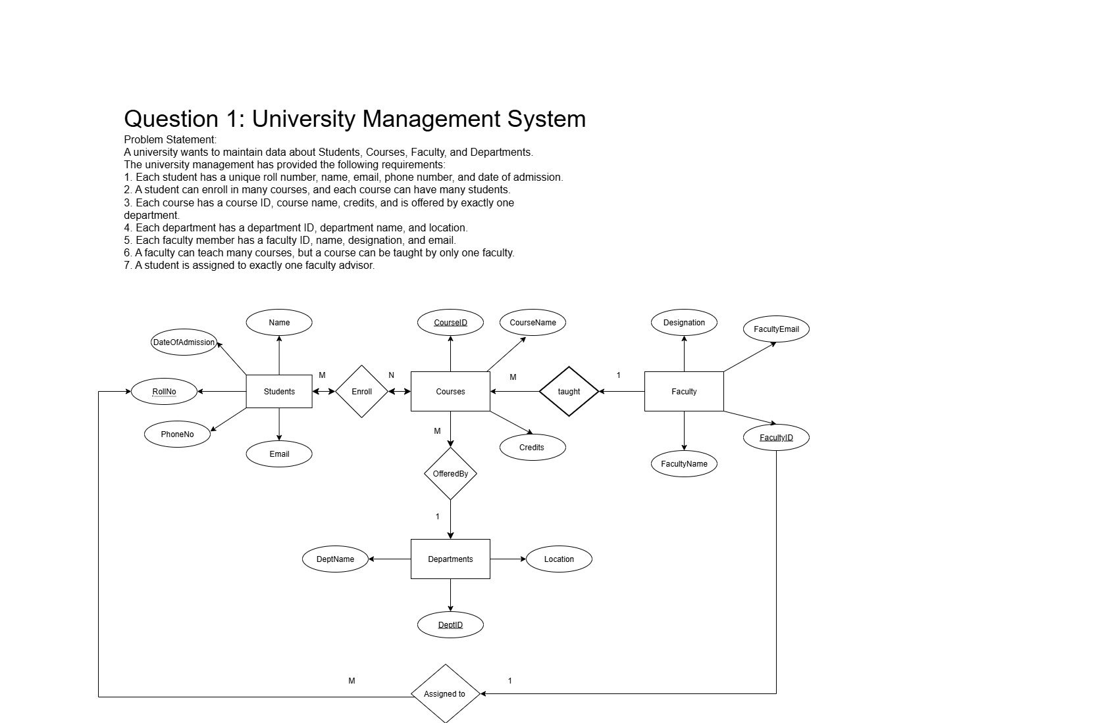

1. Convert to Tables (Optional Advanced Task) – Convert your ER diagram into relational schema (tables with PK and FK).

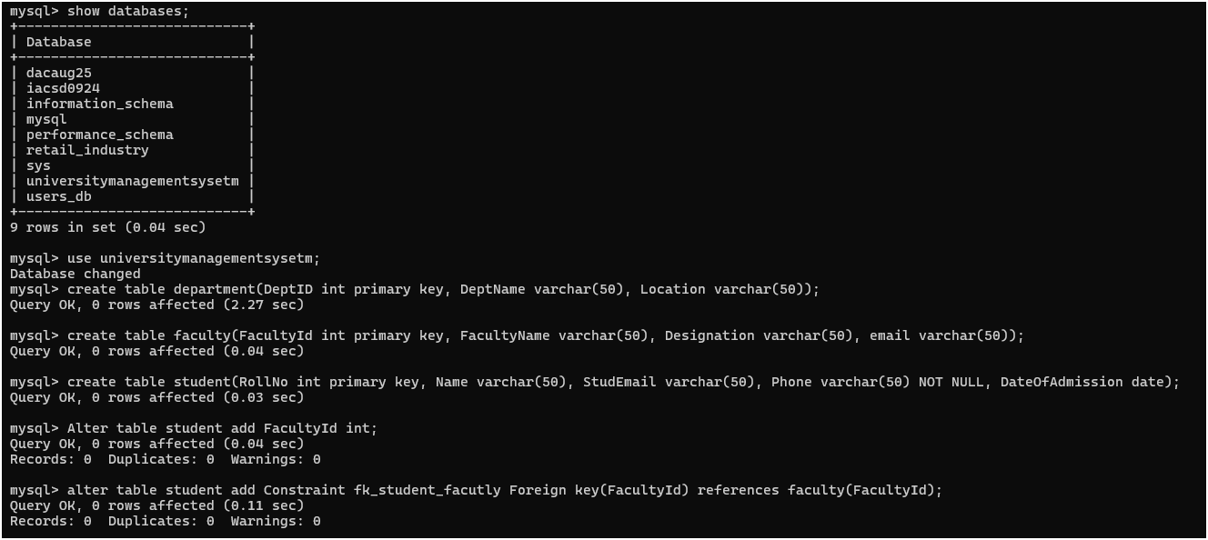

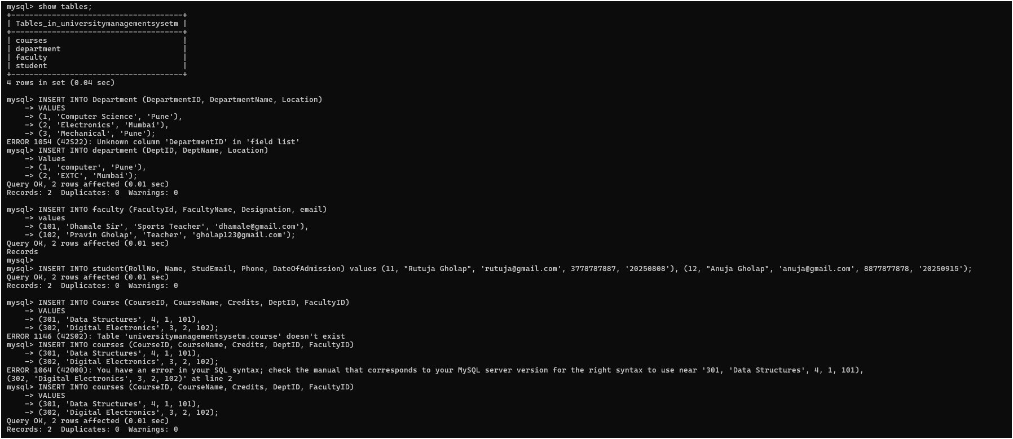

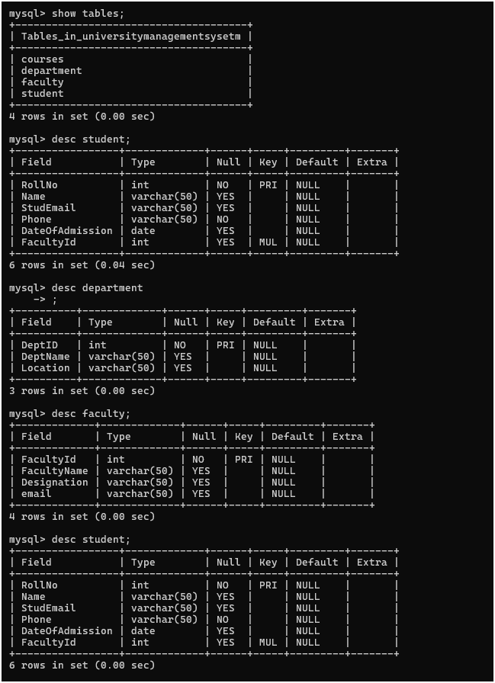

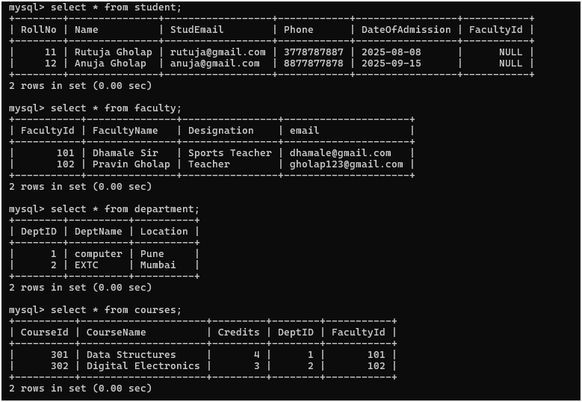

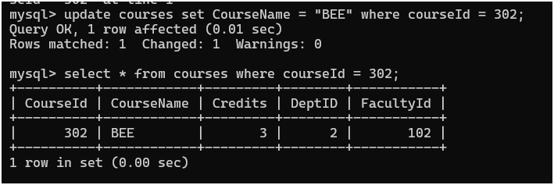

**Question 2: Online Shopping System**

Problem Statement:

An online shopping portal wants to maintain information about Customers, Orders,

Products, Payments, and Delivery. The requirements are as follows:

1. Each customer has a customer ID, name, email, phone, and address.

2. A customer can place many orders, but each order belongs to only one customer.

3. An order has an order ID, order date, total amount, and status.

4. Each order can contain multiple products, and a product can appear in many orders

(many-to-many relationship).

5. Each product has a product ID, name, description, price, and stock quantity.

6. Each order must have one payment, which includes payment ID, payment date, amount,

and mode of payment (UPI, Credit Card, COD).

7. Each order is linked to a delivery, which includes delivery ID, delivery date, delivery

status, and delivery address.

Tasks

1. Identify Entities & Attributes – List entities and attributes (with primary keys).

|  |  |  |
| --- | --- | --- |
| **Entity** | **Attributes** | **Primary Key (PK)** |
| Customer | customerID, name, email, phone, address | customerID |
| Order | orderID, orderDate, totalAmount, status, customerID (FK) | orderID |
| Product | productID, name, description, price, stockQuantity | productID |
| Payment | paymentID, paymentDate, amount, mode, orderID (FK) | paymentID |
| Delivery | deliveryID, deliveryDate, deliveryStatus, deliveryAddress, orderID (FK) | deliveryID |

1. Define Relationships – Show all relationships with correct cardinalities.

|  |  |  |
| --- | --- | --- |
| **Relationship** | **Entities Involved** | **Cardinality** |
| Places | Customer → Order | 1 Customer → Many Orders |
| Contains | Order ↔ Product | Many-to-Many |
| Makes | Order → Payment | 1 Order → 1 Payment |
| Delivered By / Linked To | Order → Delivery | 1 Order → 1 Delivery |

1. Draw the ER Diagram – Use proper ER notation for entities, attributes, and relationships.

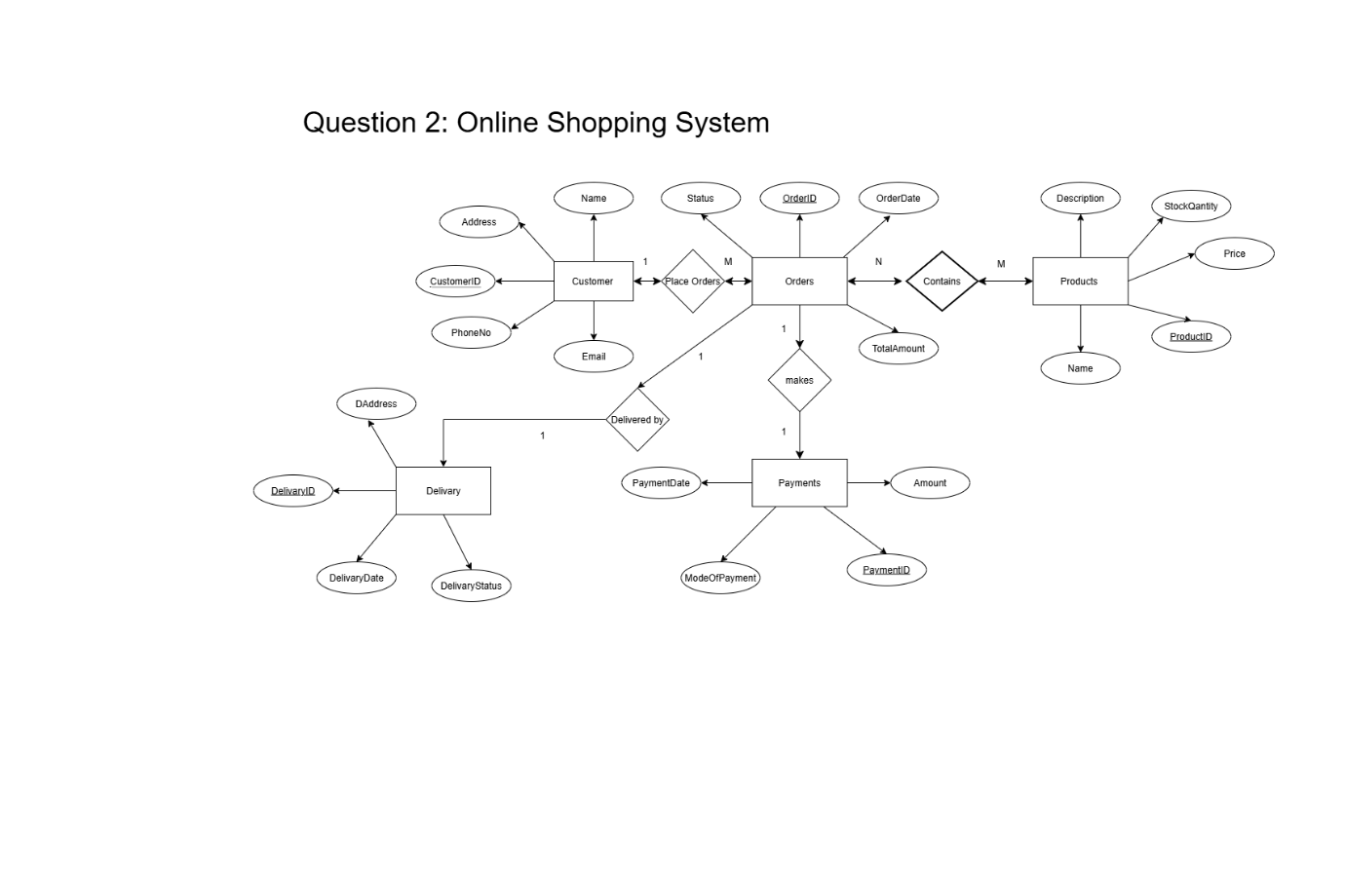

1. Optional Task – Convert ER diagram into relational schema (tables with PK and FK)

